# **LAB 1**

1. Go to the official website of Virtual Box and download it.

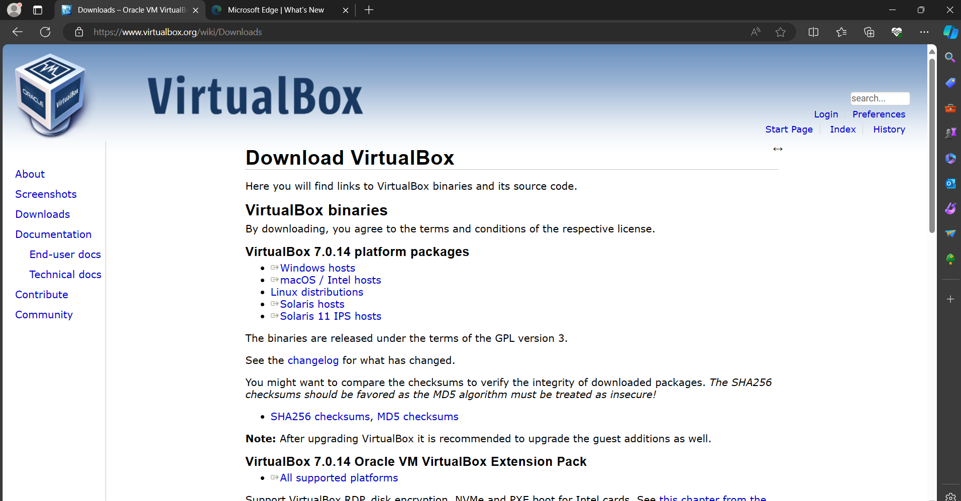

1. Install the Virtual Box.

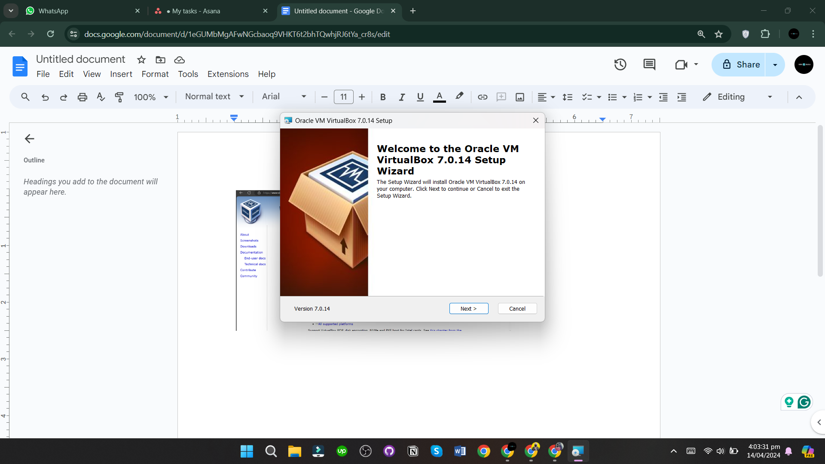

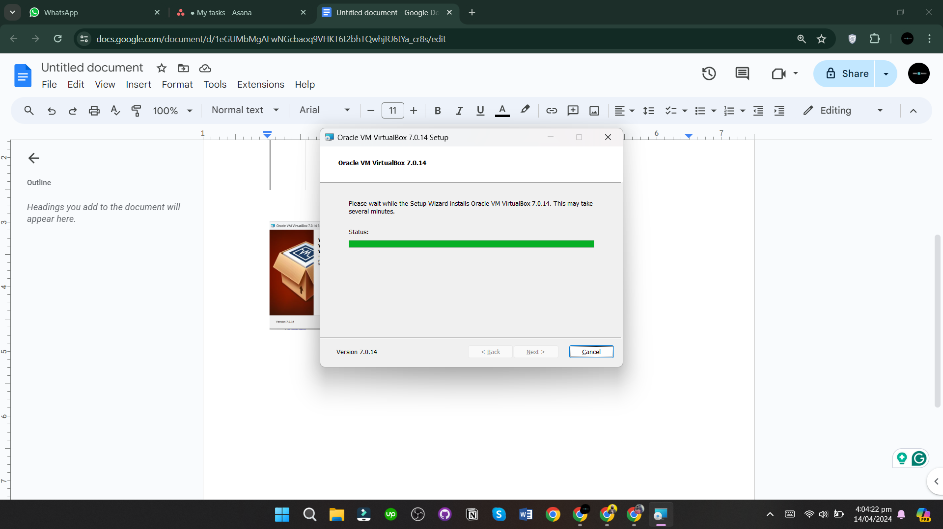

1. Now open the Virtual Box.

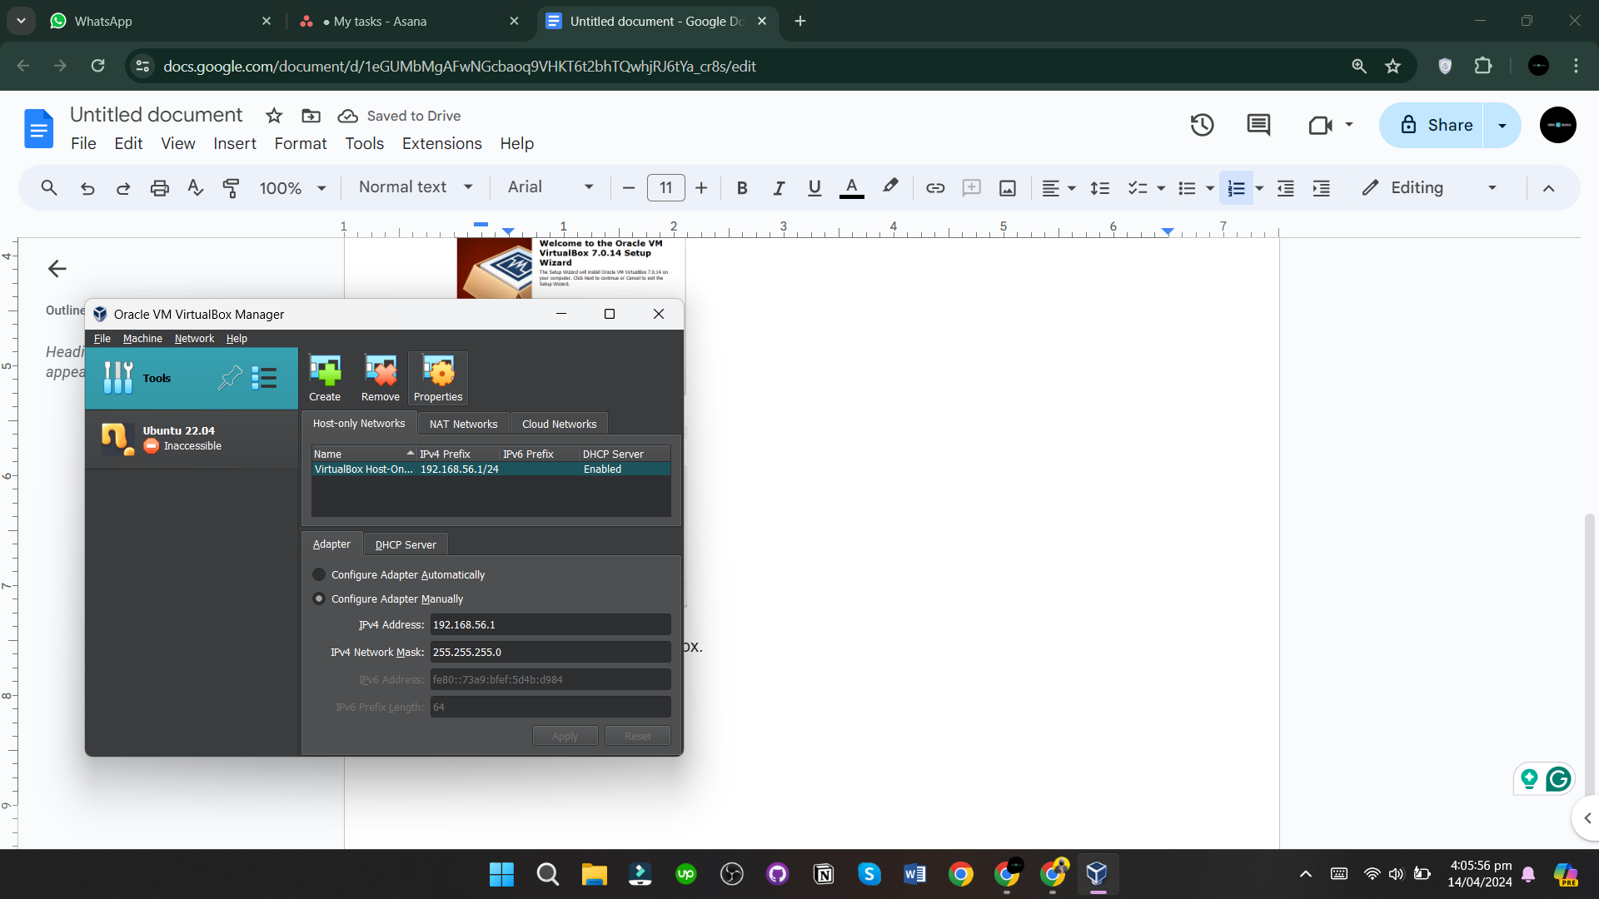

1. Click on New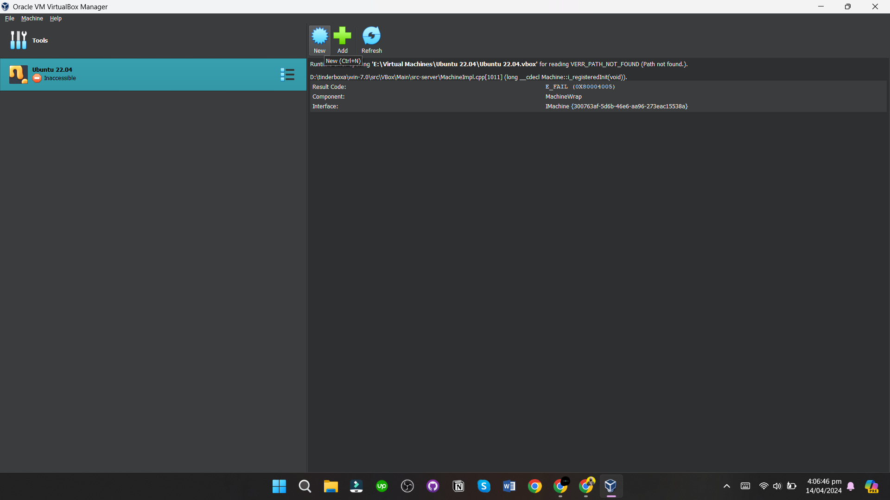
2. Add the name of your own choice, then select Linux and Ubuntu 32-bits.

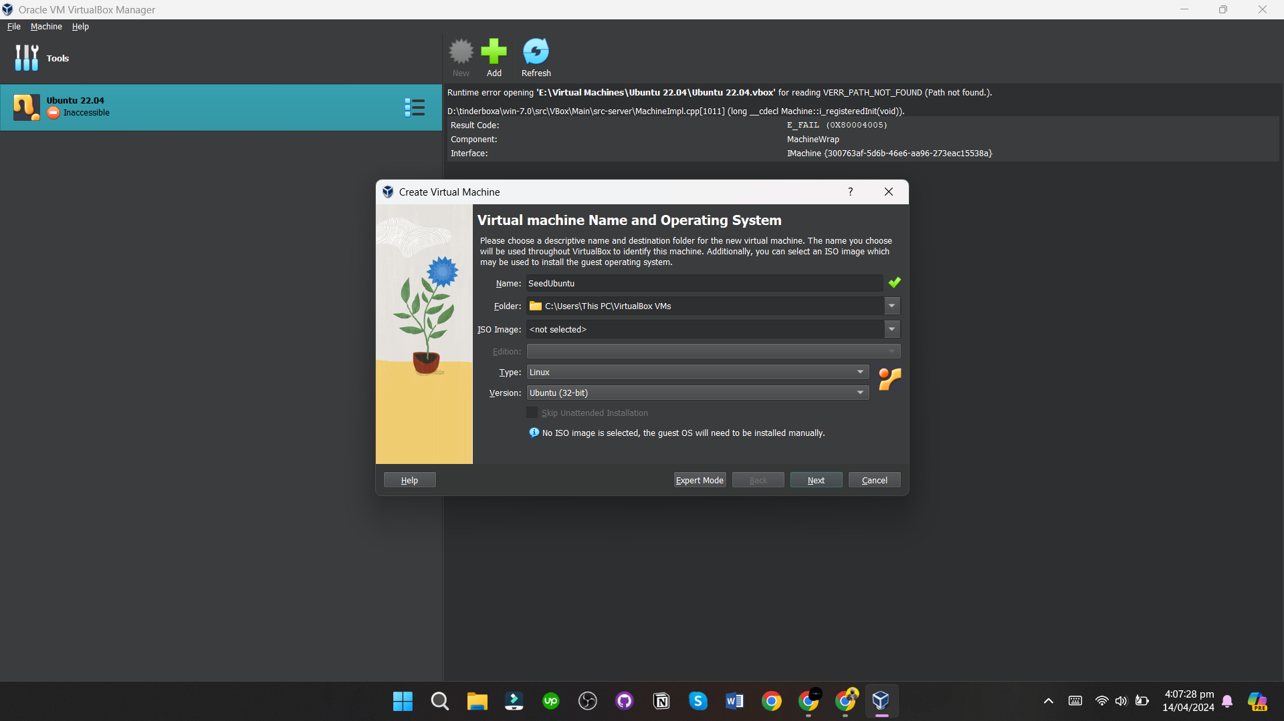

1. Set the memory size to 1024MB

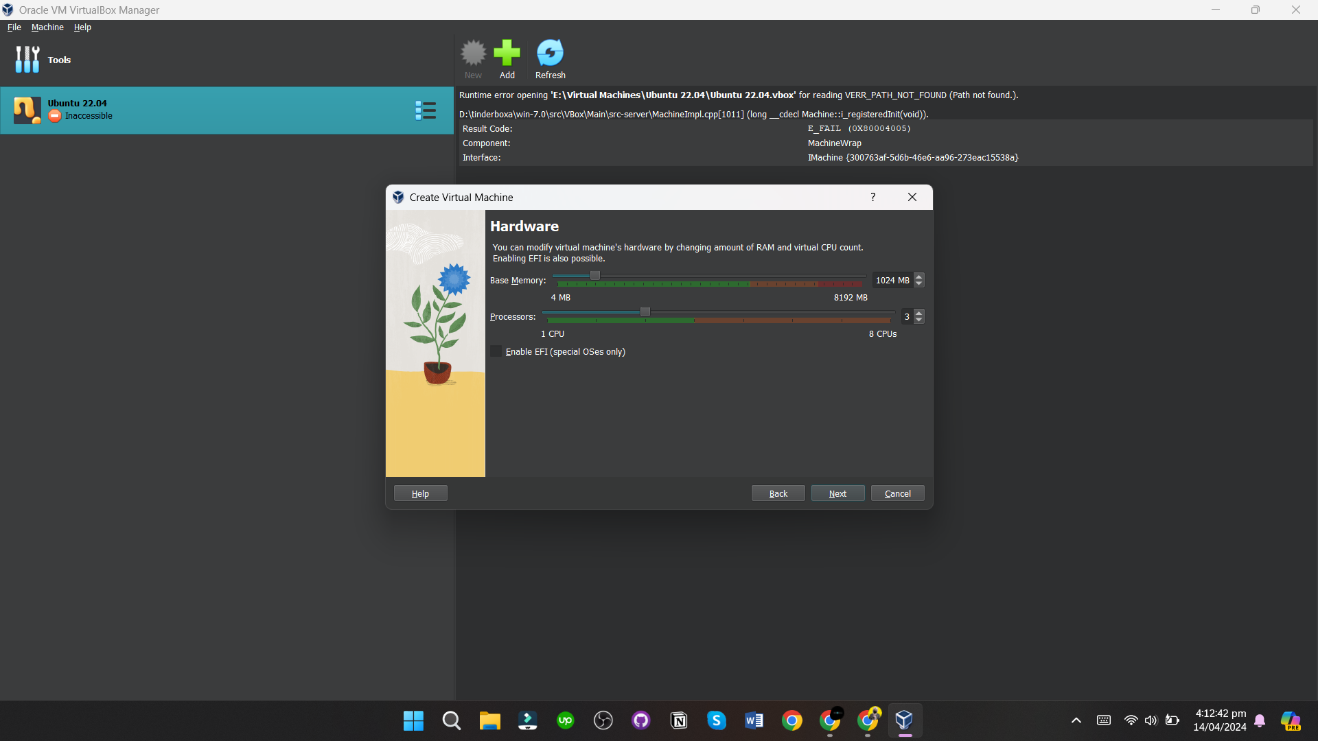

1. Successfully created.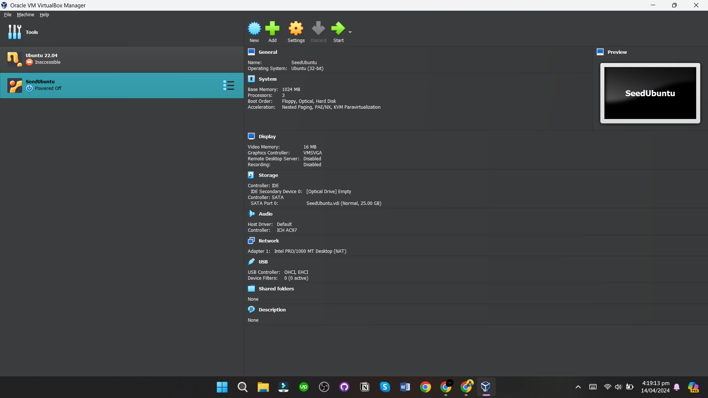
2. Go to settings -> Advanced tab -> Select bidirectional for both.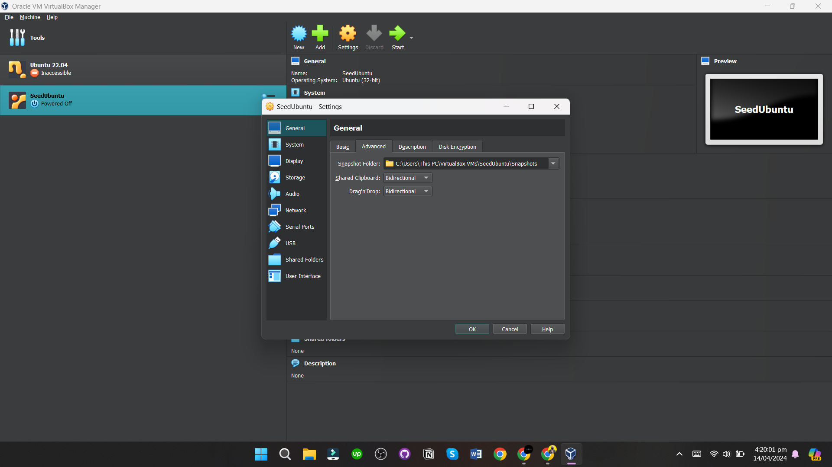
3. Go to Display -> Select VBoxVGA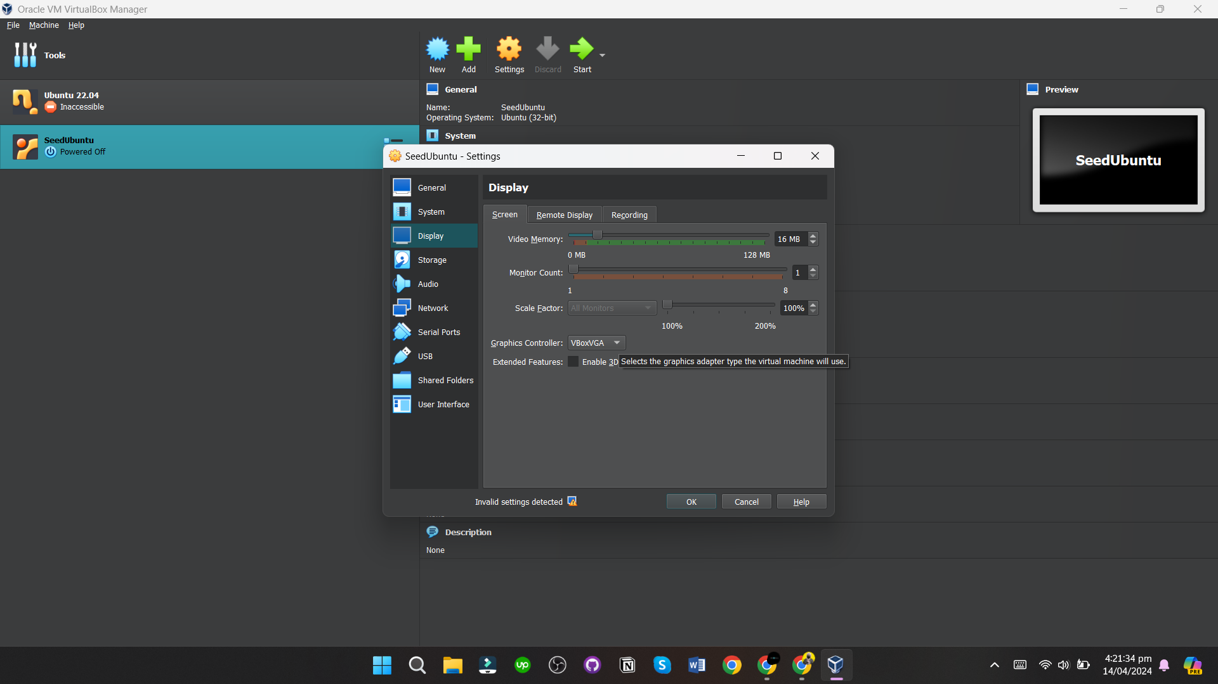
4. After starting the VM, stop the VM and save the state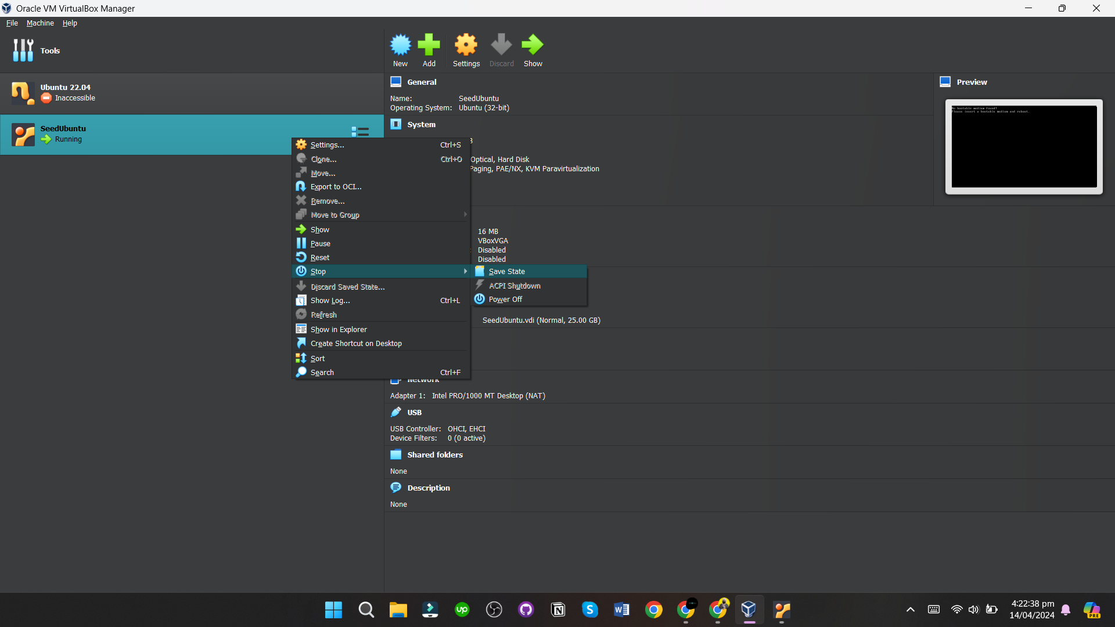
5. Clone 3 more machines and name them Attacker, Victim and Client.